LAB 10

10. Build an application to do a stock display using PWA using a raw JSON file

Step 1:

Manifest.json

{

"name": "Stock Display",

"short_name": "Stock-Display",

"display": "standalone",

"start_url": "/",

"id": "/",

"description": "Display stock from json file",

"icons": [

{

"src": "assets/logo.png",

"type": "image/png",

"sizes": "512x512",

"purpose": "maskable"

},

{

"src": "assets/logo.png",

"type": "image/png",

"sizes": "512x512",

"purpose": "any"

}

],

"background_color": "#00AA00",

"theme_color": "#00CC00"

}

Step2:sw.js

(function(){

self.addEventListener('install',event =>{

console.log('service worker installing');

self.skipWaiting();

})

self.addEventListener('activate',event=>{

console.log('service worker activating...')

})

self.addEventListener('fetch',event=>{

console.log('fetching',event.request.url);

})

})

()

Step3: data.json

[

{

"company": "3M",

"description": "Im in RVCE",

"initial_price": 44.28,

"price_2002": 56.27,

"price_2007": 95.85,

"symbol": "MMM"

},

{

"company": "Amazon.com",

"description": "Under VTU",

"initial_price": 89.38,

"price_2002": 17.01,

"price_2007": 93.43,

"symbol": "AMZN"

}

]  
  
Step4: index.html

<!DOCTYPE html>

<html>

<head>

<title>Stock Display</title>

<link rel="manifest" href="manifest.json">

<style>

table {

border-collapse: collapse;

}

td, th {

padding: 1em;

border: 1px solid black;

}

</style>

</head>

<body>

<center>

<h2>Stock Market Data Display</h2>

<div id="stock"></div>

</center>

<script>

if ('serviceWorker' in navigator) {

navigator.serviceWorker.register("sw.js")

.then((e) => {

if (e.active === null) {

console.log("registered");

}

});

} else {

console.log("browser does not support service worker");

}

fetch("data.json")

.then((res) => {

return res.json();

})

.then((stock) => {

var table = "<table><tr><th>Company</th><th>Description</th><th>Initial Price</th><th>Price in 2007</th><th>Symbol</th></tr>";

for (item of stock) {

table += "<tr><td>" + item.company + "</td><td>" + item.description + "</td><td>" + item.initial_price + "</td><td>" + item.price_2007 + "</td><td>" + item.symbol + "</td></tr>";

}

table += "</table>";

document.getElementById("stock").innerHTML = table;

});

</script>

</body>

</html>

OUTPUT:

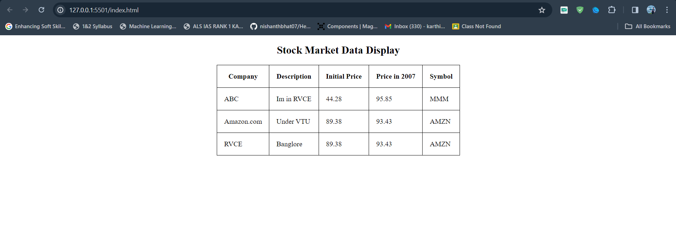

Go to service worker > Network > No throttling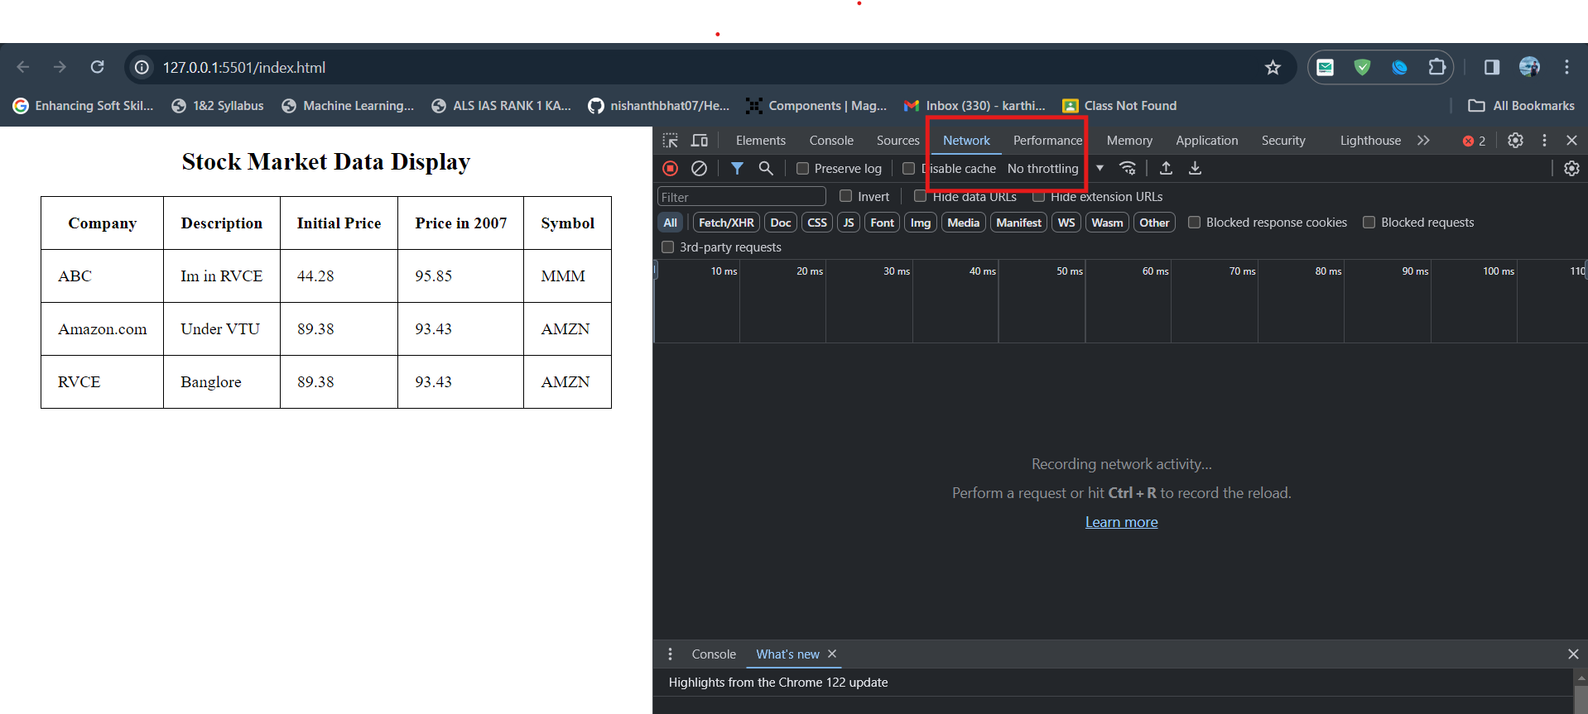

Refresh the Service worker data fetched 